Analysis of ESP32_MAX5443_CV_GUI_0.0.txt
Overview
This is the original firmware using the MAX5443 DAC, controlling the CV experiment and sending ADC data back to the GUI.
Section-by-Section Breakdown
- Setup (setup):
  - Initializes SPI and serial at 115200 baud, sets the DAC to a midpoint value (1.25V) for 0V at the working electrode (V_WE).
  - Observation: The midpoint = 1.25V suggests a different level-shifting setup than the current 1.0V, but the principle of offsetting applies.
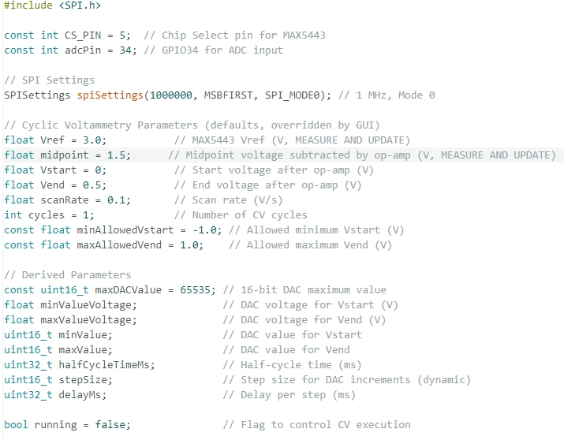
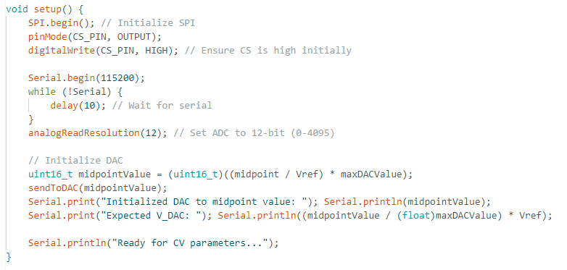
- Loop (loop):
  - Listens for serial commands (START: or STOP).
  - Observation: The structure relies on running to trigger runCyclicVoltammetry() once per START: command, which may limit cycle execution.
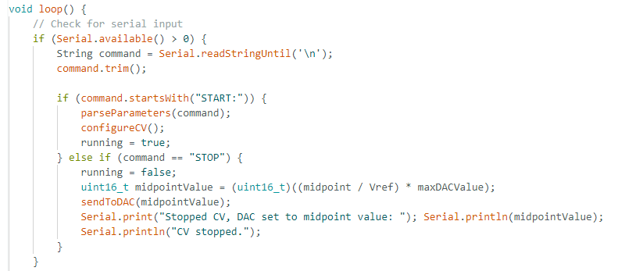
- Parameter Parsing (parseParameters):
  - Extracts Vstart, Vend, scanRate, and cycles from the START: command.
  - Validates ranges (-1.0V to 1.0V) and logs the received values.
  - Observation: The parsing logic is correct, matching the GUI’s command format.
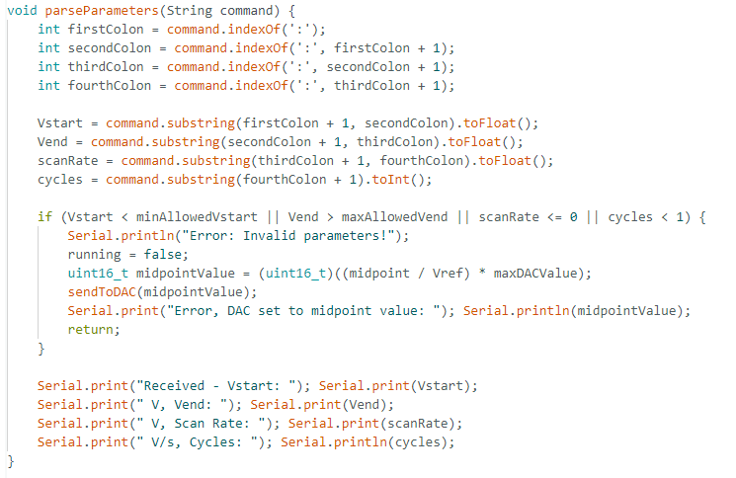
- CV Configuration (configureCV):
  - Calculates DAC values (minValue, maxValue) based on Vstart + midpoint and Vend + midpoint, scaled to the MAX5443’s 0-3V range (0-65535 codes).
  - Computes halfCycleTimeMs as (Vend - Vstart) / scanRate * 1000, with a dynamic stepSize for ~1000 steps per half-cycle.
  - Observation: The voltageRange = Vend - Vstart is correctly used, but the step size and delay calculation might not scale properly if scanRate is misinterpreted.
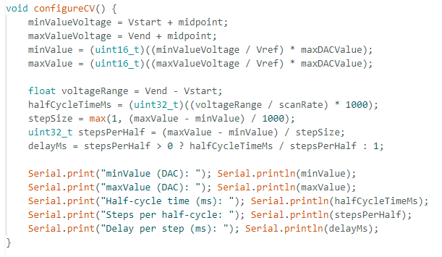
- CV Execution (runCyclicVoltammetry):
  - Runs cycles full cycles, with a triangular waveform (rising to maxValue, then falling to minValue).
  - Sends ADC values to the serial port and adjusts the DAC with delayMs.
  - Observation: The loop exits after one full cycle per iteration, and cycles controls the outer loop. If running is set false prematurely (e.g., by a stop or buffer issue), it won’t complete all cycles.
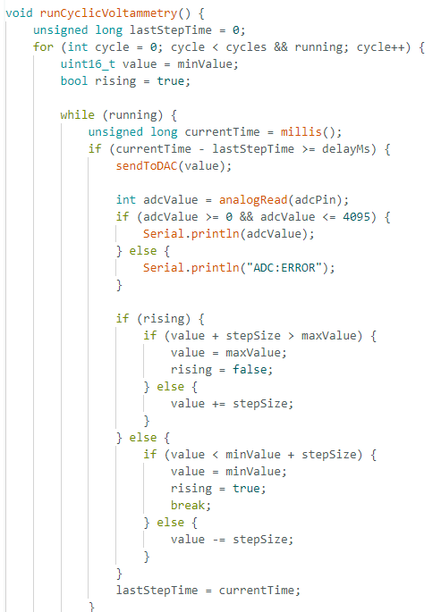
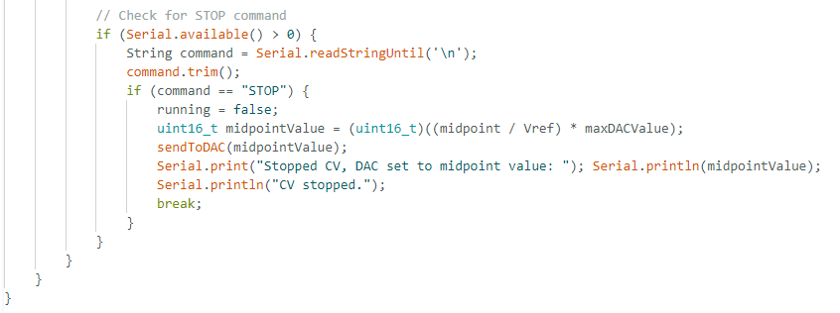
- DAC Communication (sendToDAC):
  - Writes a 16-bit value to the MAX5443 via SPI.
  - Observation: No issues; the current AD5761 firmware uses a similar SPI approach.
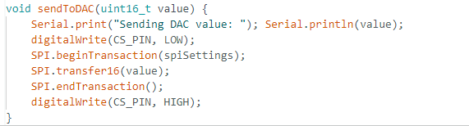
Key Insight:
The firmware executes one cycle per runCyclicVoltammetry() call, controlled by cycles. If the GUI’s START: command triggers only one call or running is reset, it explains the single-cycle issue. The scanRate affects halfCycleTimeMs, but if the firmware uses a default range (e.g., -1.5V to +1.5V from the AD5761 setup), it could override the GUI’s Vstart and Vend.

